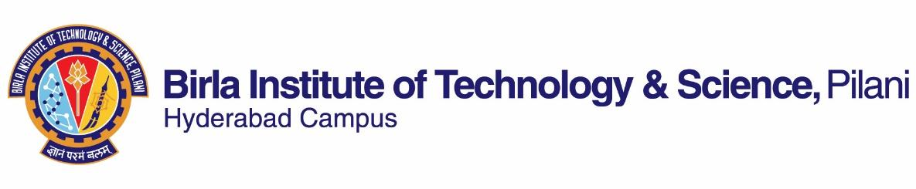

**FIRST SEMESTER 2023-2024**

# Course Handout Part II

Date: 11-08-2023

In addition to part-I (General Handout for all courses appended to the time table) this portion gives further specific details regarding the course.

*Course No.* : HSS F249

## Course Title : Politics in India

## Instructor-in-Charge : Dr. Lavanya Suresh

**Scope and Objective of the Course:**

India is a diverse country and has sustained a thriving democracy for decades. In its functioning, the Indian democracy deals with various complex issues juxtaposed against each other. The country is defined by great cultural diversity on the one hand and, on the other, the presence of deep social and economic inequality. Some state institutions that deal with these complexities have flourished and strengthened our democracy, while others have not. There is a constant negotiation of political space, ideologies, and identities by the state, political parties, and civil society. A constant challenge faced by the Indian democracy is its capacity to redistribute wealth and alleviate poverty. This Politics in India course will address these issues and help students understand the complexity that defines Indian politics.

**COURSE OBJECTIVES**

After completing the course, students will be able to

* Understand political institutions that define democracy in India.
* Elaborate on the connection between social cleavages, identity, and politics.
* Discuss and analyse political processes.
* Analyse the challenges faced by the Indian democratic state.

**Textbooks:**

Jayal, N. G. & Mehta, P. B. (eds.) (2011) *The Oxford Companion to Politics in India*: Student Edition. New Delhi: Oxford University Press.

**Reference books**

* Tiwari, R.K. (eds.) (2019) Political Parties, Party Manifestos and Elections in India, 1909–2014. Oxon and New York: Routledge.
* Kapur, D. & Khosla, M. (eds.) (2019) Regulation in India: Design, Capacity, Performance. New Delhi: Hart Publishing.
* Chhibber, P.K. & Verma, R. (2018) Ideology and Identity: The Changing Party Systems of India. New Delhi: Oxford University Press.
* Vaishnav, Milan. (2017) When Crime Pays: Money and Muscle in Indian Politics. New Delhi: Harper Collins Publishers.
* Kothari, Rajni. (2012). Politics in India. New Delhi: Orient Blackswan.

**Course Plan:**

|  |  |  |  |
| --- | --- | --- | --- |
| **Lecture No.** | **Learning objectives** | **Topics to be covered** | **Chapter in the Text Book** |
| 1-4 | To understand  the structure of the Indian state after Independence in the context of its colonial legacy | **Unit I: The Institutional Setting** : The State - Transformed structures of political power | Chapter 1 |
| 5-7 | To contemplate the Indian Constitution and the Constituent Assembly Debates (1946-9) | Constitutionalism – Vision, power and evolution | Chapter 2 |
| 8-10 | To study India’s bicameral parliamentary democracy | Parliament - Origin, structures, practices | Chapter 3 |
| 11-13 | To analyse the process of fragmentation of the Indian party system at the national level | The Party System - Fragmentation, Alliances | Chapter 8 |
| 14-17 | To examine the relationship between class and politics in India | **Unit II**: **Social Cleavages, Identity, and Politics :** Class and Politics | Chapter 9 |
| 18-20 | To analyse democratic political processes in terms of castes and communities | Caste and Politics | Chapter 10 |
| 21-23 | To examine the relationship between religion and politics in India | Religion and Politics | Chapter 14 |
| 24-26 | To explore the significance of identity and agency | Politics and National Identity | Chapter 13 |
| 27-30 | To study the significance of political parties as an institution | **Unit III: Political Processes :**Political Parties - National parties, coalitions, critical issues | Chapter 16 |
| 31-33 | To discuss social justice and the state | Social Justice - State and social justice | Chapter 24 |
| 34-36 | To examine the role of major collective campaigns in Independent India | Social Movements | Chapters 25 and 26 |
| 37-40 | To assess the state’s role in addressing inequality | Politics and Redistribution – History, state variation, corruption | Chapter 33 |

**Evaluation Scheme:**

|  |  |  |  |  |
| --- | --- | --- | --- | --- |
| **Component** | **Duration** | **Weightage (%)** | **Date & Time** | **Nature of Component** |
| Assignments | TBA | 30 | TBA | Open Book |
| Mid-semester Test | 90 mnts | 30 | 09/10 - 11.30 - 1.00PM | Closed Book |
| Comprehensive Examination | 180 mnts | 40 | 06/12 AN | Closed Book |

**Chamber Consultation Hour:** Will be announced on CMS.

**Notices:** Notices concerning the course will be displayed on **CMS only**.

**Make-up Policy:** Make-up component will be allowed provided there is documentary support to prove the authenticity of the case. In granting make-up, the decision of the instructor-in-charge will be final.

**Academic Honesty and Integrity Policy:** Academic honesty and integrity are to be maintained by all the students throughout the semester and no type of academic dishonesty is acceptable.

Dr. Lavanya Suresh

**INSTRUCTOR-IN-CHARGE**